

Property Energy Consumption Prediction

Team 07



September 28, 2020

VIRTUSA

B-Cipher & Neural Hack Competition

Abstract

Energy prediction is an essential component in the first step to create a management plan in EMS. To build an efficient system, it is necessary to predict energy demand according to various conditions. We have developed a solution to predict energy consumption using Machine Learning Algorithm. The solution is Primarily provided to predict energy consumption for a single building or Property and Multiple properties at the same time by upload a spreadsheet of required property details. Solution is built by training the model using historic energy consumption along with weather and property details for each time series record of a year. Solution is built using Random Forrest Regression Technique. This solution will provide your energy consumption for every hour by inputting required details.

Executive Summary

The Machine Learning Solution will predict the energy consumption of every building or a property for each hour. Solution has been built by training the model with meter readings of properties along with weather and building properties to consider the multiple factors of energy consumption. We have considered time series data of each hour for over a year for different properties.

The model development includes Data Engineering, Feature Selection, Model Selection, Model building. The model uses Random forest algorithm to predict number of unit consumptions per hour. The model test accuracy is approximately 87% and the AUC score is 0.98. These are the best performance metrics for the model, this is achieved using the hyper-parameter tuning

To better facilitate the client, we have development web application to access the solution. The features of the frontend were developed using JavaScript, HTML and CSS. The web application provides excellent features to the client by facilitating both single building prediction and predict for multiple buildings by uploading a file. It provides detailed description about the advantages of predicting energy consumption beforehand.

The interface also provides access to his/her previous prediction history stored in Postgres Database. To secure the data, the web application is authenticated only upon logging into his/her account.

My dashboard feature of web application provides quick insights of customer’s previous prediction data to help in decision making for the customer. The web application is also equipped with chatbot to facilitate user with understanding different fields and components of web application.

Contents

Introduction and Business Background 4

Problem Statement 5

Business Solution 5

Value Proposition of Solution 5

Data Extraction 5

Dataiku 6

Data Description Using Dataiku 7

Feature Transformation/Engineering in Dataiku 15

Merging Datasets 15

Data Preprocessing 15

Model Development in Dataiku 16

Sampling Methods (Dataiku) 17

Hyper-Parameter Tuning (Dataiku) 18

Performance Metrics 18

Extracting Model (Dataiku) 19

Web PEP Application 19

Development Environment 19

Application Elements 20

User Interface 21

Bootstrap 21

jQuery 21

Django 23

AJAX 23

Charts.js 24

Database 25

Chatbot 27

Other UI Screen 29

References 31

Table of Figures

Figure 1 Dataiku Flow 6

Figure 2 Left Join using dataiku 15

Figure 3 Preprocessing and Build 16

Figure 4 Model Training 17

Figure 5 Sampling 18

Figure 6Hyperparameter Tunning 18

Figure 7 Performance Metrics 19

Figure 8 User Prediction History - Dashboard 21

Figure 9 Login Screen 22

Figure 10 AJAX Function 24

Figure 11 Multiple input or file Upload Screen 24

Figure 12 SQLite3 DB 25

Figure 13 Admin Portal 26

Figure 14 Resource Utilization 26

Figure 15 Chatbot 28

Figure 16 Single Input Screen 29

Figure 17 Home Screen 29

Figure 18 About US 30

Figure 19 User Profile Screen 31

# Introduction and Business Background

## Problem Statement

Energy is an essential part of our lives and almost all things in some way are associated with electricity. The amount of energy we use keeps growing, and with that comes increased greenhouse gas emissions. Due to improper usage, a tremendous amount of energy is wasted annually; hence, energy wastage can be avoided by efficient utilization of energy.

## Business Solution

An energy consumption prediction is very significant to achieve efficient energy maintenance and reduce environmental effect.

With the advent of machine learning, accurately predicting future energy consumption becomes increasingly possible.

Our solution, Property Energy Predictor, would efficiently help customers to provide accurate energy consumption predictions along with many additional features.

## Value Proposition of Solution

1. Economic: Companies and individuals can translate energy into cost, and therefore estimate their energy bill, and make decisions based on this.
2. Practical: By not only knowing how much energy we will consume, but understanding how and why we will, we can change our habits without affecting our productivity or the quality of our lives.
3. Technical: Better managing energy data unlocks new possibilities in the collection and analysis of this data, as well as in generating more accurate predictions.

Data Extraction

Data Source

The dataset includes three years of hourly meter readings from over one thousand buildings at several different sites around the world.

Dataset Source: <https://www.kaggle.com/c/ashrae-energy-prediction/data>

Dataset has 5 different files for timeseries data, building meta data and weather data.

train.csv

1. building_id - Foreign key for the building metadata.
2. meter - The meter id code. Read as {0: electricity, 1: chilled water, 2: steam, 3: hot water}. Not every building has all meter types.
3. timestamp - When the measurement was taken
4. meter_reading - The target variable. Energy consumption in kWh (or equivalent). Note that this is real data with measurement error, which we expect will impose a baseline level of modeling error. UPDATE: as discussed here, the site 0 electric meter readings are in kBTU.

building_meta.csv

1. site_id - Foreign key for the weather files.
2. building_id - Foreign key for training.csv
3. primary_use - Indicator of the primary category of activities for the building based on EnergyStar property type definitions
4. square_feet - Gross floor area of the building
5. year_built - Year building was opened
6. floor_count - Number of floors of the building

weather_[train/test].csv

Weather data from a meteorological station as close as possible to the site.

1. site_id
2. air_temperature - Degrees Celsius
3. cloud_coverage - Portion of the sky covered in clouds, in oktas
4. dew_temperature - Degrees Celsius
5. precip_depth_1_hr - Millimeters
6. sea_level_pressure - Millibar/hectopascals
7. wind_direction - Compass direction (0-360)
8. wind_speed - Meters per second

# Dataiku

Property energy Predictor solution model is built on Dataiku. Data Science Studio (DSS) from Dataiku is a complete Data Science software tool for developers and analysts, which significantly shortens the time-consuming load-clean-train-test-deploy cycles of building predictive applications.

Figure 1 Dataiku Flow

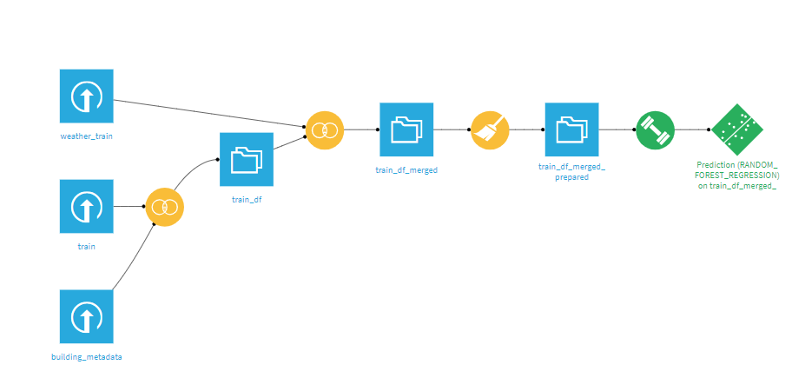

Dataiku has been used to perform Data cleaning, Data Preprocessing and Model building while developing the solution

# Data Description Using Dataiku

**Building_id**

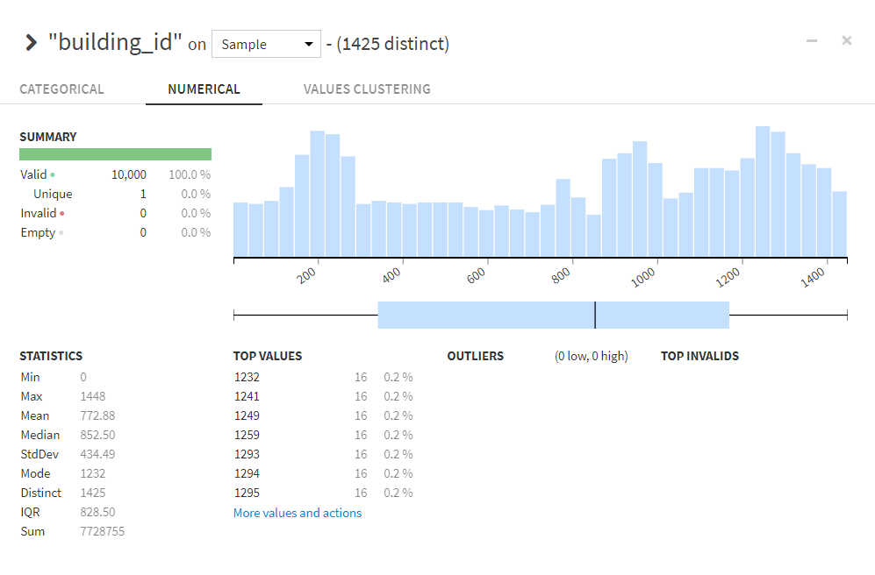

**Meter**

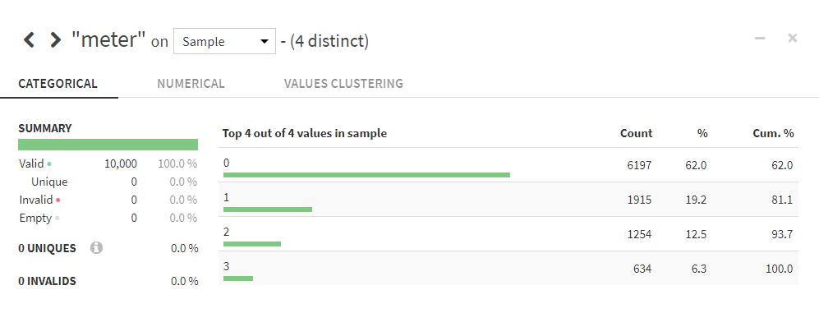**Timestamp**

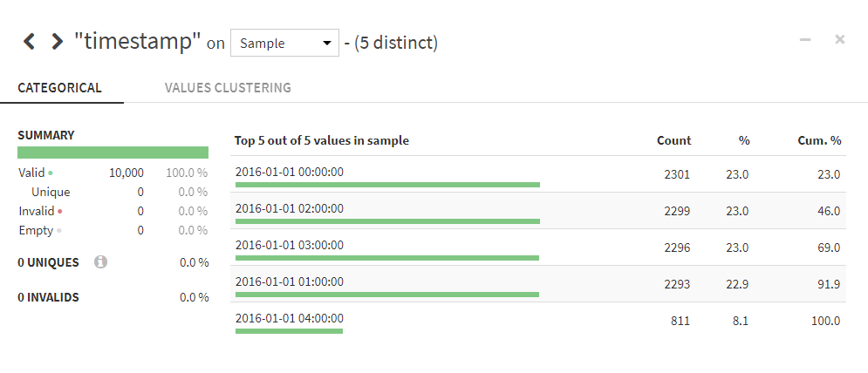**Meter_reading**

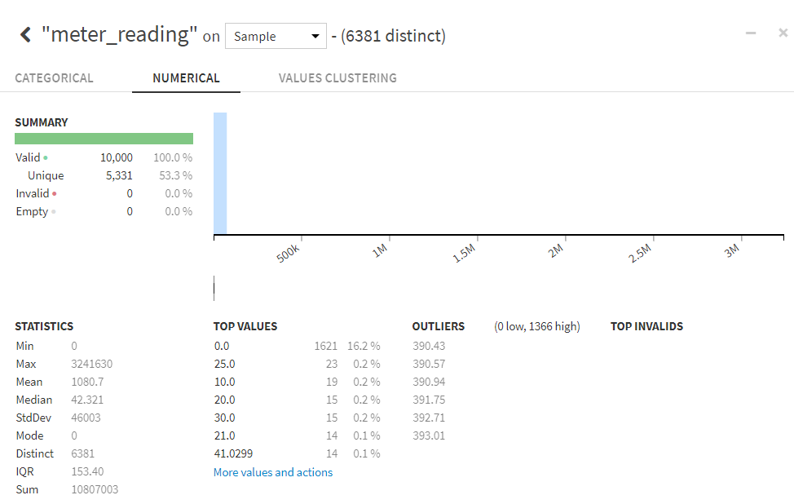

**Site_id**

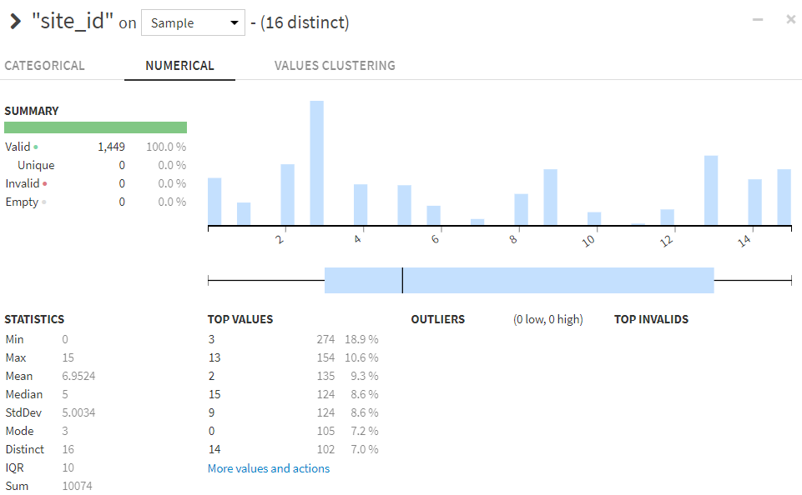

**Primary_use**

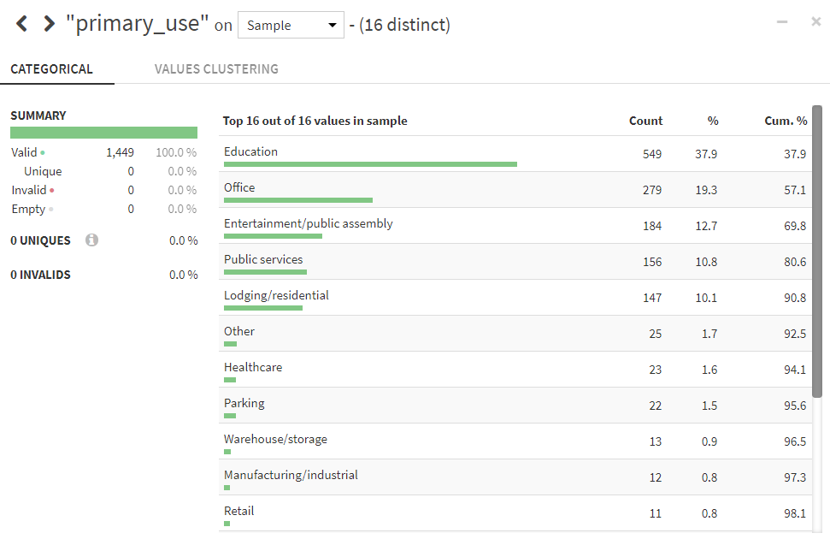

**Square_feet**

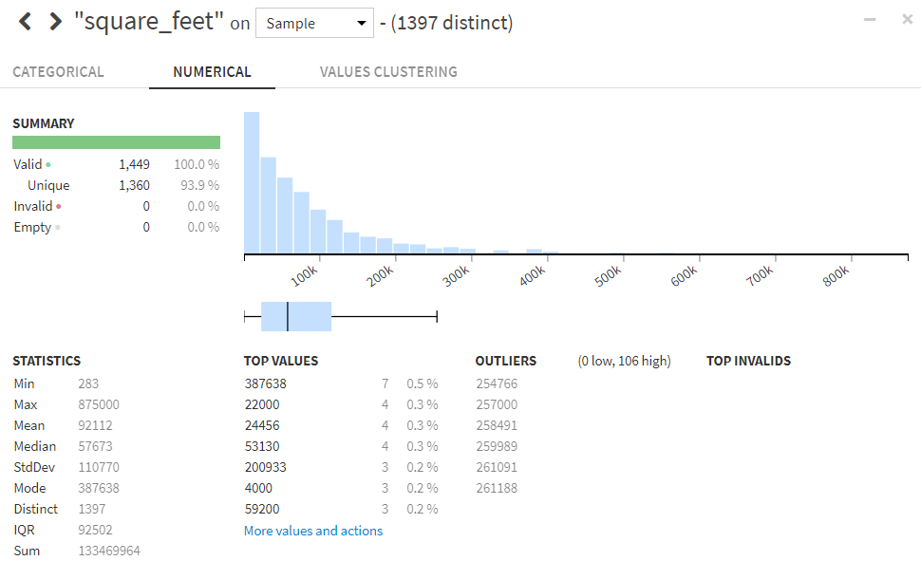

**Year_built**

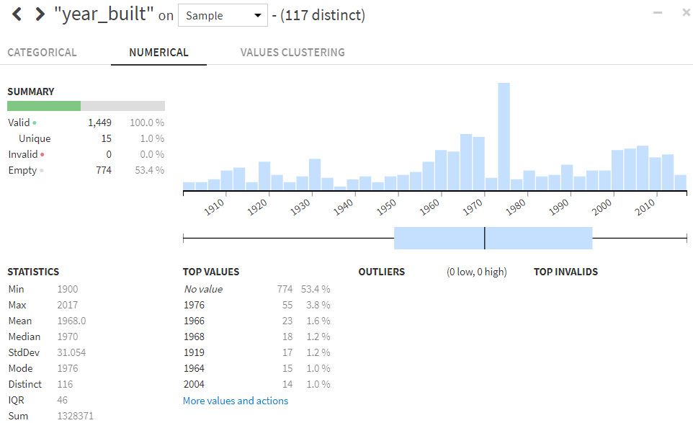

**Floor_count**

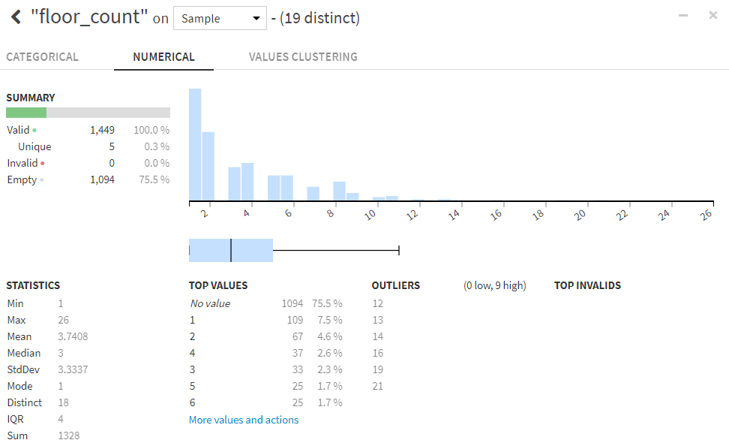

**Air_temperature**

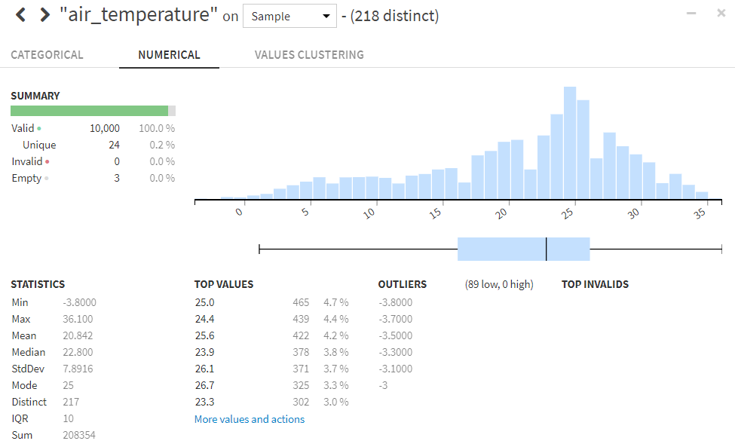

**Cloud_coverage**

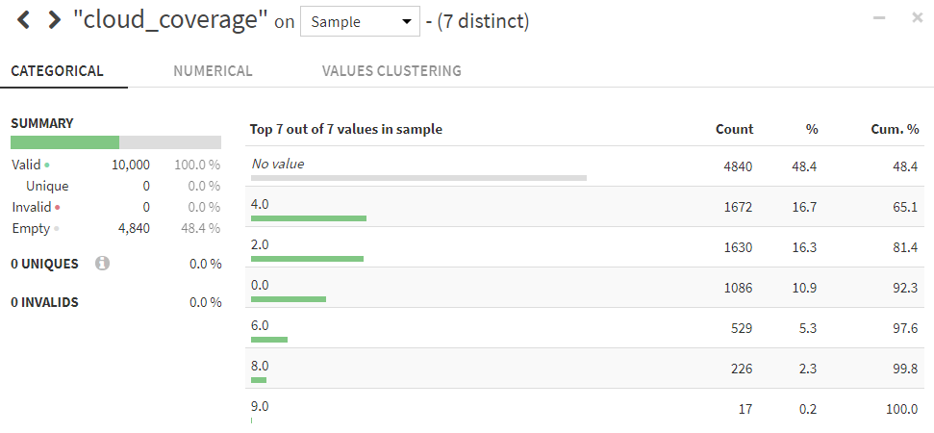

**Dew_temperature**

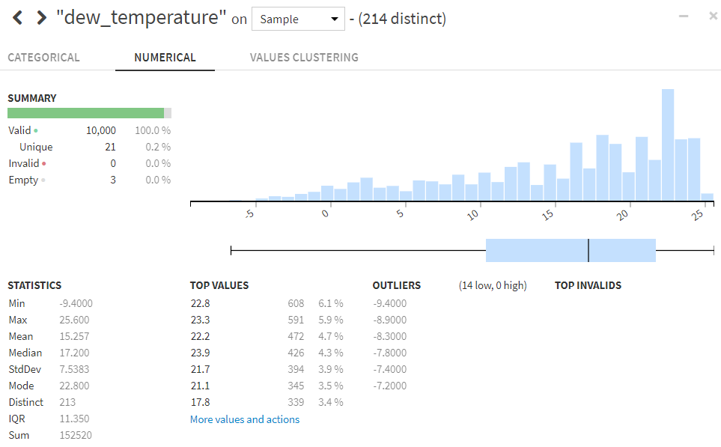

**Precip_depth_1hr**

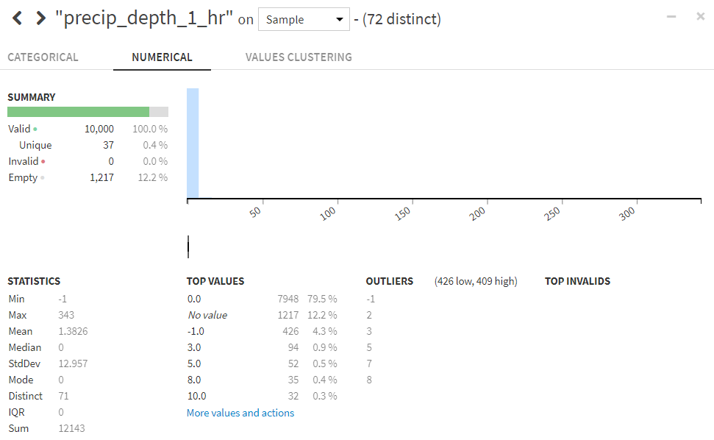

**Sea_level_pressure**

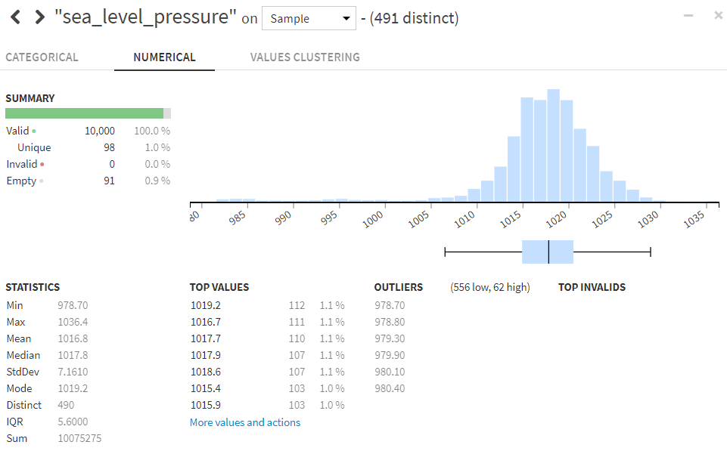

**Wind_direction**

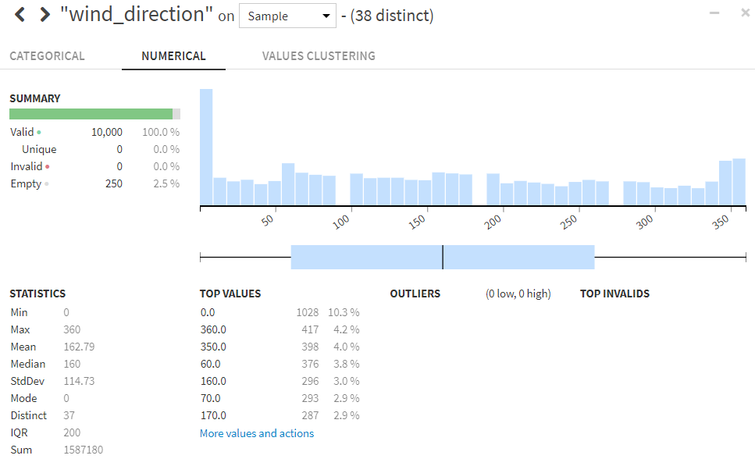

**Wind_speed**

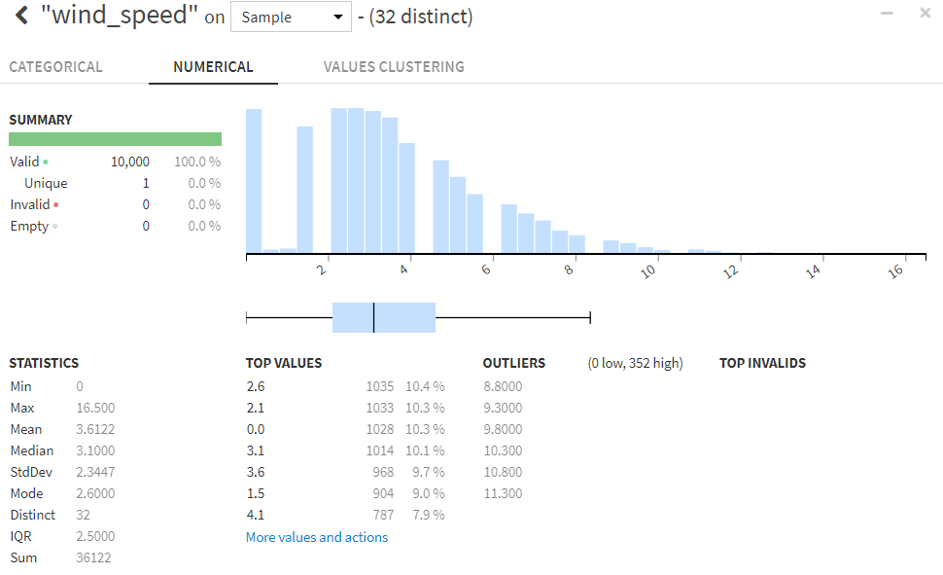

# Feature Transformation/Engineering in Dataiku

## Merging Datasets

All three files (train.csv, building data and weather data) are joined using Join recipe in Dataiku. This has been done for both test and train datasets available.

The “join” recipe is dedicated to joins between two or more datasets. DSS handles inner joins, left outer joins and full outer joins.

Join recipe can only performed on 2 datasets at a time. Hence left join is performed two times in Dataiku.

Figure 2 Left Join using dataiku

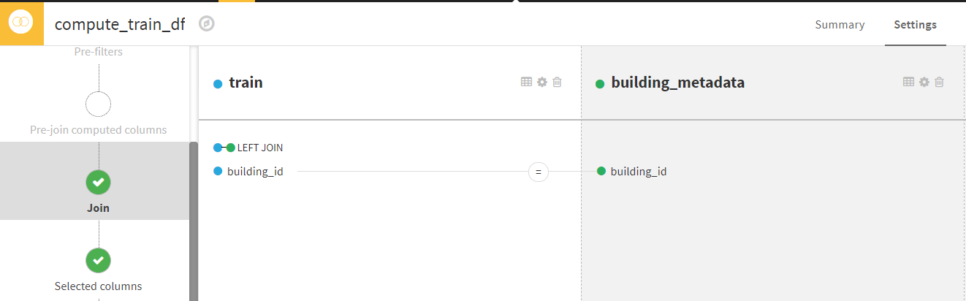

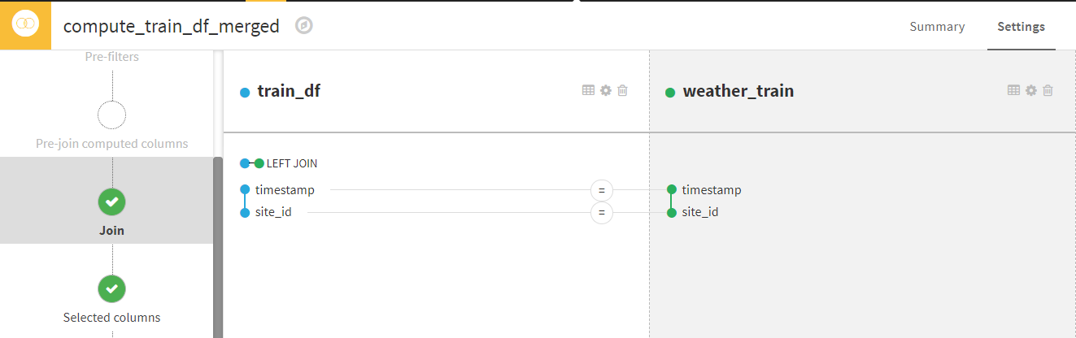

## Data Preprocessing

Data has been preprocessed using dataiku Prepare recipe. The Prepare recipe lets you create data cleansing, normalization, and enrichment scripts in a visual and interactive way.

Here, we have created a Prepare recipe from scratch or deploy it from a Visual Analysis in the Lab.

Preprocessing steps in dataiku:

1. Remove rows having meter reading 0.

2. Remove rows having empty values in year_built.

3. Fill empty cells of cloud_coverage with mode.

4. Fill empty cells of precip_depth_1_hr with mode.

5. Fill empty cells of dew_temperature with average.

5. Fill empty cells of sea_level_pressure with average.

6. Fill empty cells of wind_direction with average.

7. Fill empty cells of wind_speed with average.

8. Fill empty cells of floor_count with mode.

9. Parsed the timestamp column.

Figure 3 Preprocessing and Build

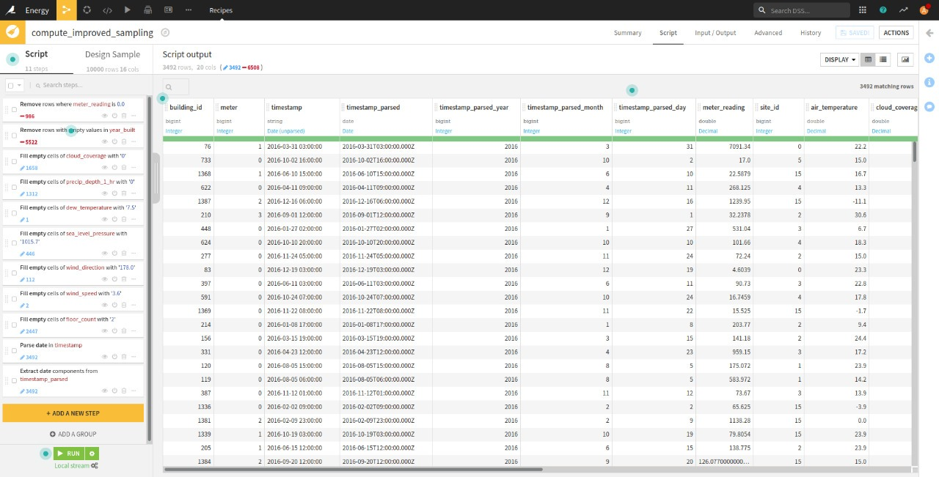

Throughout the process used the analyze option to get analysis of each column for better judgement.

Transformation of Categorical Variables has been performed by “One hot encoding” and finally data is scaled to make it standardized during the predictions.

# Model Development in Dataiku

Once the Data is ready, we have developed the model for merged training dataset by selecting the target variable as meter reading.

Different Models used by dataiku automatically to train are:

1. Random Forest

2. Gradient Boosted Trees

3. XGBoost

4. Decision Tree

5. K Nearest Neighbors

Figure 4 Model Training

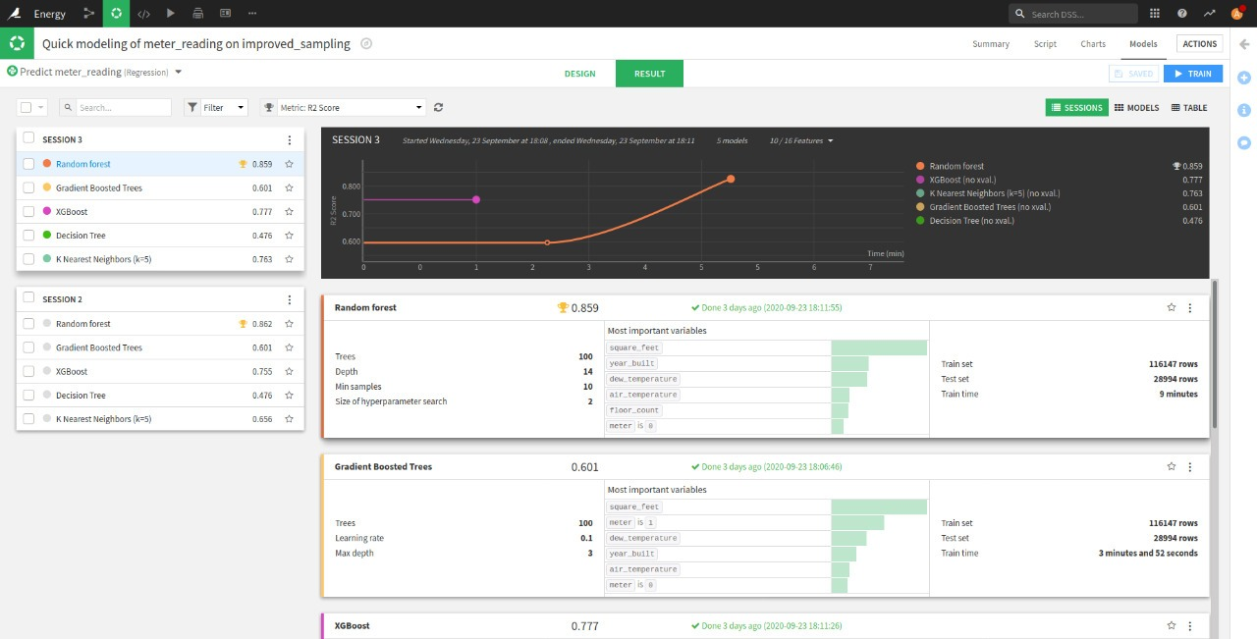

After few passes, we chose top 2 scoring model for deeper analysis

1. Random Forest

2. XGBoost

## Sampling Methods (Dataiku)

class rebalance and random sampling as the whole data was too large to load into memory.

Figure 5 Sampling

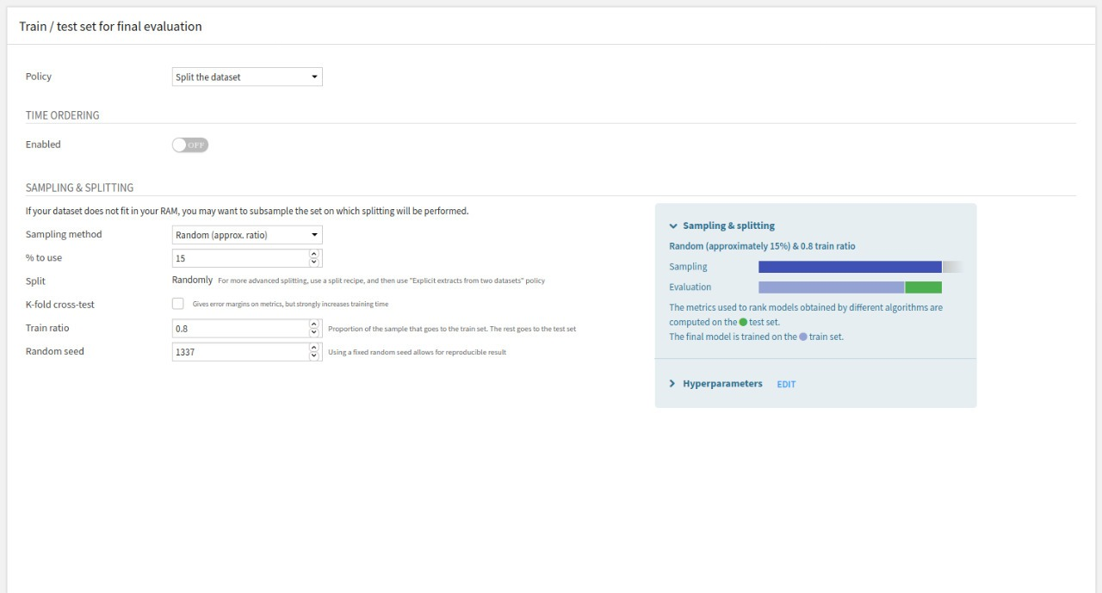

## Hyper-Parameter Tuning (Dataiku)

hyperparameter tuning used grid search and random search.

Figure 6Hyperparameter Tunning

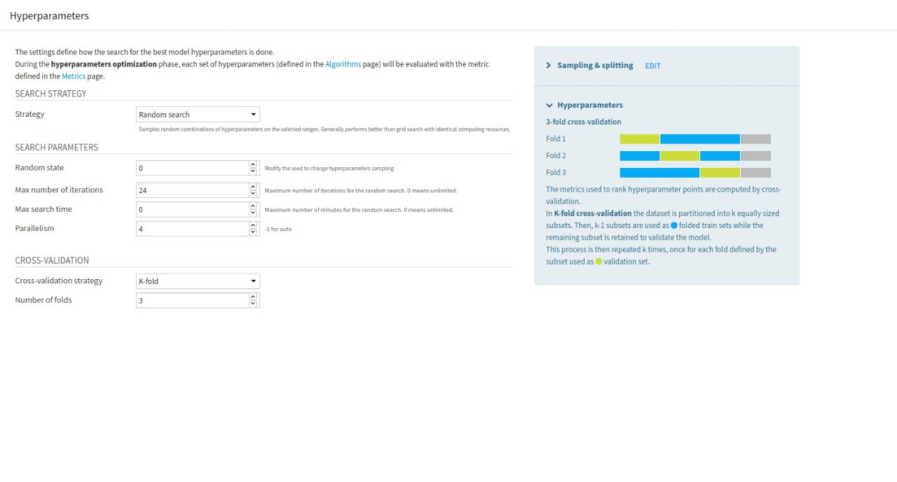

## Performance Metrics

Dataiku Random Forest Model was built with strong accuracy of 87% approx.

Figure 7 Performance Metrics

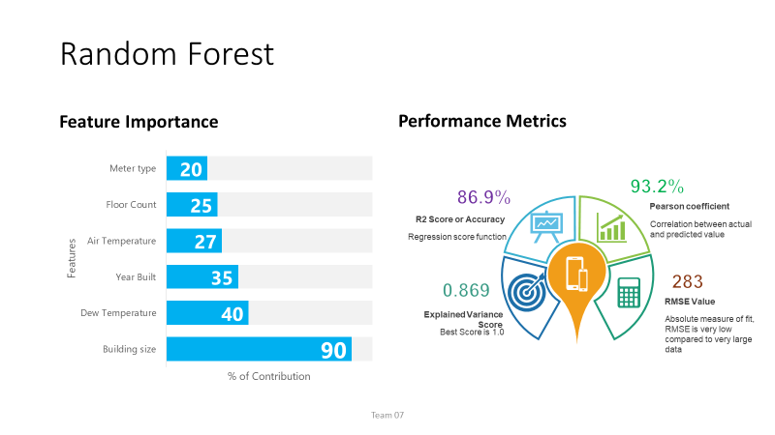

## Extracting Model (Dataiku)

On getting satisfactory scores used jupyter notebook to extract pickle file of chosen model (Random Forest, acc=87%).

We have pickled the model, by following commands in Dataiku notebook.

m = dataiku.Model("rf_model")

my_predictor = m.get_predictor()

my_clf = my_predictor._clf

filename = 'rf_model.sav'

pickle.dump(my_clf, open(filename, 'wb'))

# Web PEP Application

### Development Environment

|  |  |
| --- | --- |
| Software/technologies/Frameworks | Description |
| GitHub | Version control repository |
| Jupyter/AWS | Cloud computing platform |
| Bootstrap | UI Framework/Theme (HTML5 and CSS3) |
| Python | Programming Language |
| Database | SQLlite3 |
| Django | Programming framework for Web UI |
| AJAX | Client server Request - Response handling |
| jQuery | Programming library for Web UI |
| Charts.js | JavaScript library for data visualization |

## Application Elements

|  |  |
| --- | --- |
| Web Application Page | Description |
| Login | Login Page for Users/clients and DB Admin |
| Sign up | Signup Page for both clients |
| Forgot Password | This page allows clients to reset their password, by authentication. Will receive an OTP for user email. |
| User-home | User Landing Page which highlights Property energy Predictor solutions and its information. This page also has quick links for the same |
| User-Single PEP | 1. Single PEP solution is used to predict energy consumption for a single building. 2. Along with prediction, this solution also allows user to slip into the dashboard page to view quick insights about their predictions (only when user predicted 10 or more times) |
| User-Multi PEP | 1. Multi PEP allows users to predict energy consumption for many buildings or properties at a time. 2. Once Prediction is done, solution allows user to download the file with updated predicted column 3. User can also view summary report for his prediction using “summary” button |
| About us | About us page highlights about the solutions and the advantages of using these services |
| User-My Dashboard | Dashboard allows users to check history of predictions  Also, it provides quick insights of a user’s predictions so far |
| User-Profile | A quick view of client’s account |
| User-Change password | This page allows user to update password |
| Chatbot | Chatbot is designed to handle user queries related to fields and web application navigation |
| Admin-DB Search | DB Search allows DB Admin to navigate/access through the DB in real time. |
| Admin-User Details | Quick Snapshot of all the user profile details stored in DB. |
| Admin-Dashboard | Resource Utilization Dashboard to display CPU and Memory usage |
| Admin-Customer Pane | This page would enable Admin to access user pages with his/her login as a dummy user. To check the flow. |

# User Interface

The main technologies used in developing the front-end part are HTML5, CSS which included Bootstrap framework, JavaScript with JQuery library and AJAX.

## Bootstrap

We used bootstrap to design the initial outline of our UI. The outline of the webpage was designed using the embedded HTML and CSS of bootstrap. Depending upon the variable type two types of fields are provided: A) Text input B) Dropdown

The Dashboard Page contains the Prediction history of the user and the summary of the prediction made. The Prediction history is displayed as a table of 10 rows using Pagination of Bootstrap

Figure 8 User Prediction History - Dashboard

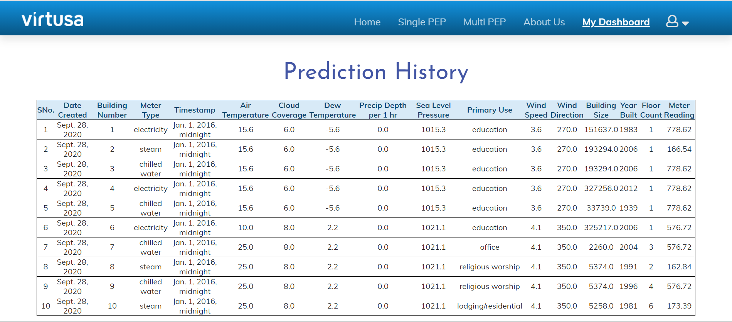

Prerequisites for implementing Bootstrap are jQuery and Django

## jQuery

jQuery is the Programming library for Web UI. The login page for both client and admin are the same. For DOM manipulations in Login and Signup pages **JQuery** was used

Figure 9 Login Screen







## Django

Web UI for the solution is developed using Django framework. Django is a high-level Python web framework that enables rapid development of secure and maintainable websites. Django is a collection of Python libs allowing you to create a quality Web application quickly and efficiently.

We have used Django framework for both backend and frontend operations and interactions with the model.

## AJAX

AJAX is Client server Request - Response handling framework. In the Multi PEP page, the user can provide multiple data using a single file. The user can either choose the file or drag and drop in the area provided.

Drag and Drop feature detection:

var isAdvancedUpload = function () {

var div = document.createElement('div');

return (('draggable' in div) || ('ondragstart' in div && 'ondrop' in div)) && 'FormData' in window && 'FileReader' in window;

}();

After drag and drop feature detection and uploading the file, the AJAX request to server:

var ajax = new XMLHttpRequest();

ajax.open(form.getAttribute('method'), form.getAttribute('action'), true);

ajax.onload = function() {

form.classList.remove('is-uploading');

if (ajax.status >= 200 && ajax.status < 400) {

location.reload();

} else alert('Error!! Please select a file before uploading');

};

Figure 10 AJAX Function

Figure 11 Multiple input or file Upload Screen

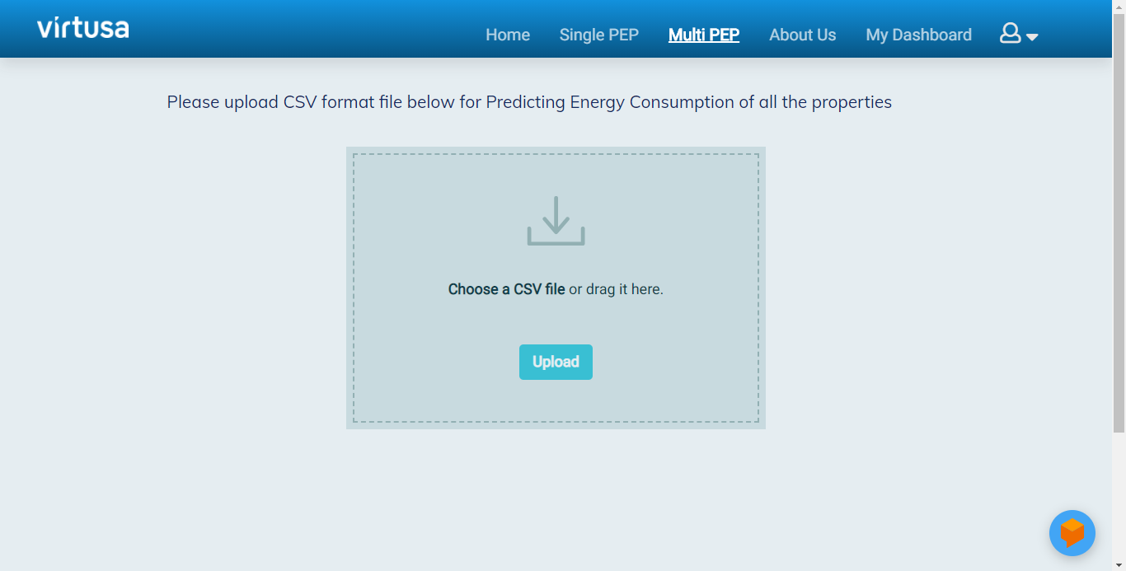

After uploading the file the user can see 3 buttons for downloading the prediction, Summary button which redirects to the user dashboard and a Go back Home button.

## Charts.js

JavaScript library for data visualization. Simple, Clean, and engaging HTML5 based JavaScript charts. Chart.js is an easy way to include animated, interactive graphs. User Dashboard provides quick insights to the users to enable them make better decisions from the insights.

function area_vs_electricity(){

var ctx= document.getElementById('chart1').getContext('2d');

var chart = new Chart(ctx,{

type : 'bar',

data : {

// X axis

labels: {{X_Area_vs_electricity|safe}},

datasets: [{

// Y label

backgroundColor: 'rgb(229,152,102,0.7)',

label: 'Mean Meter Reading',

// Y axis

data : {{Y_Area_vs_electricity|safe}},

}]

},

Here type indicates the plot type. On other hand we could provide axis names, title, styling using options tag.

# Database

SQLite is an in-process library that implements a self-contained, serverless, zero-configuration, transactional SQL database engine.

Figure 12 SQLite3 DB

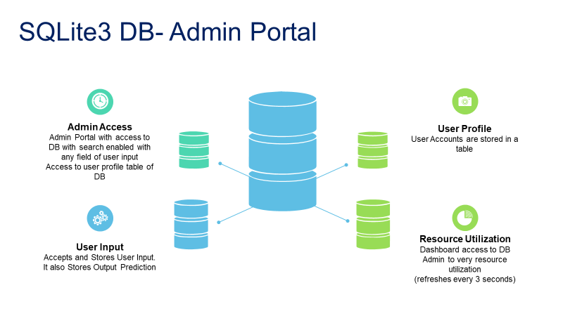

Our DB Admin Portal has explicit access to the DB details.

Figure 13 Admin Portal

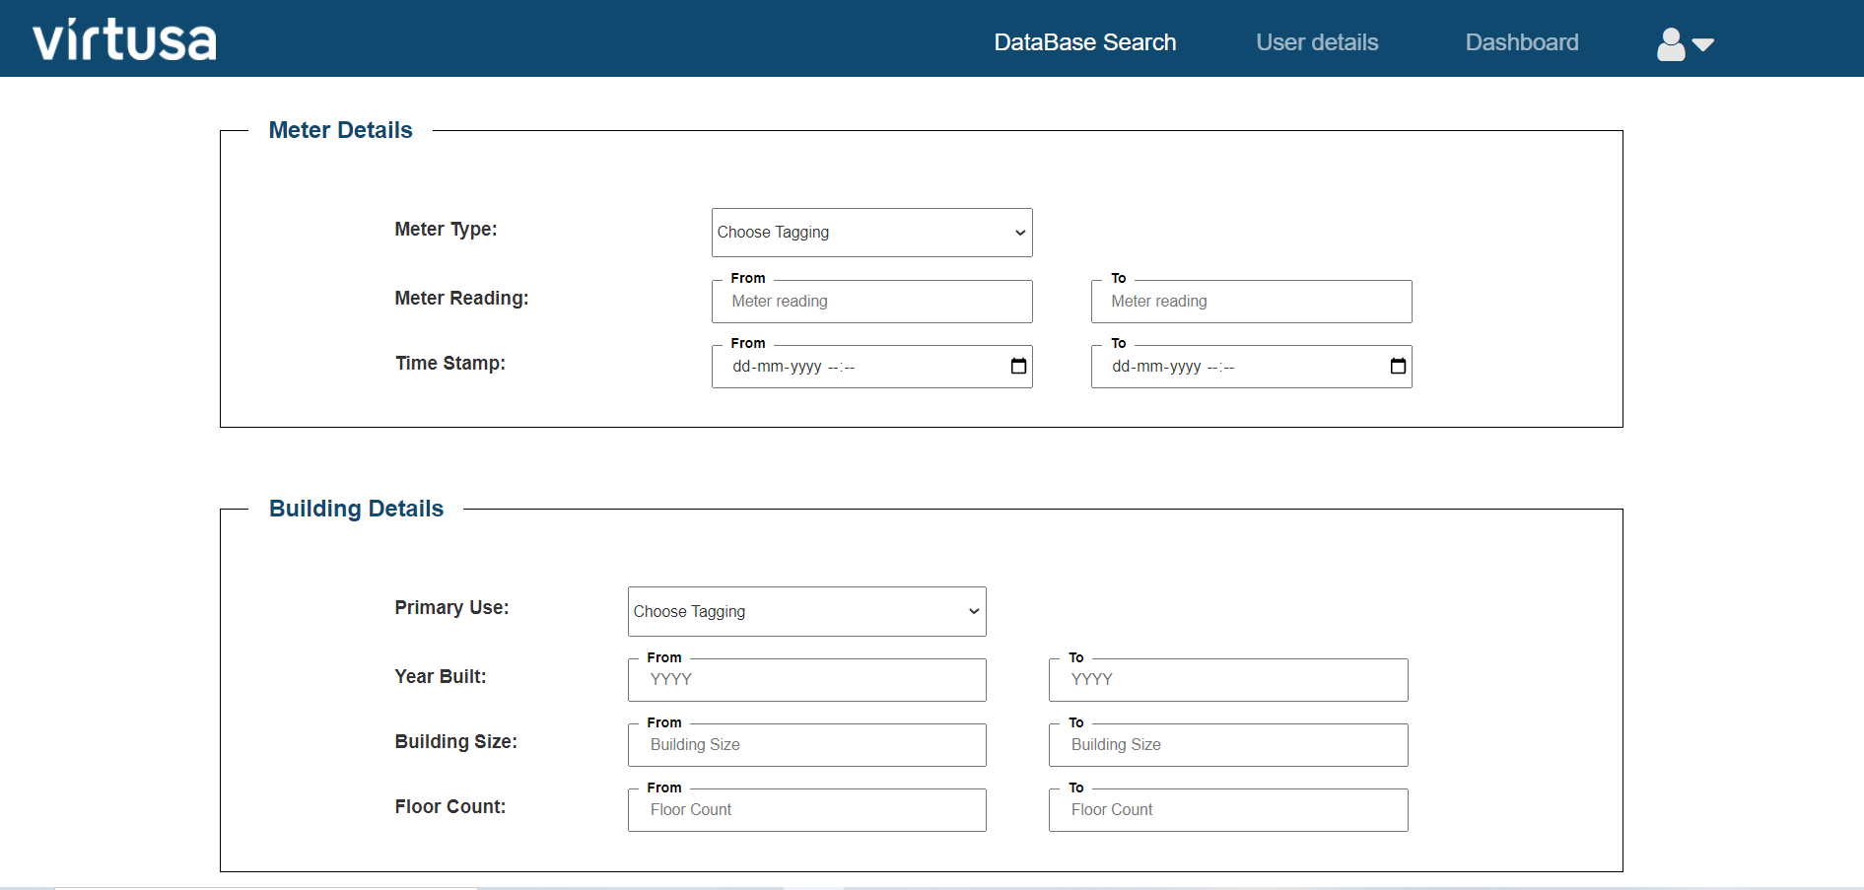

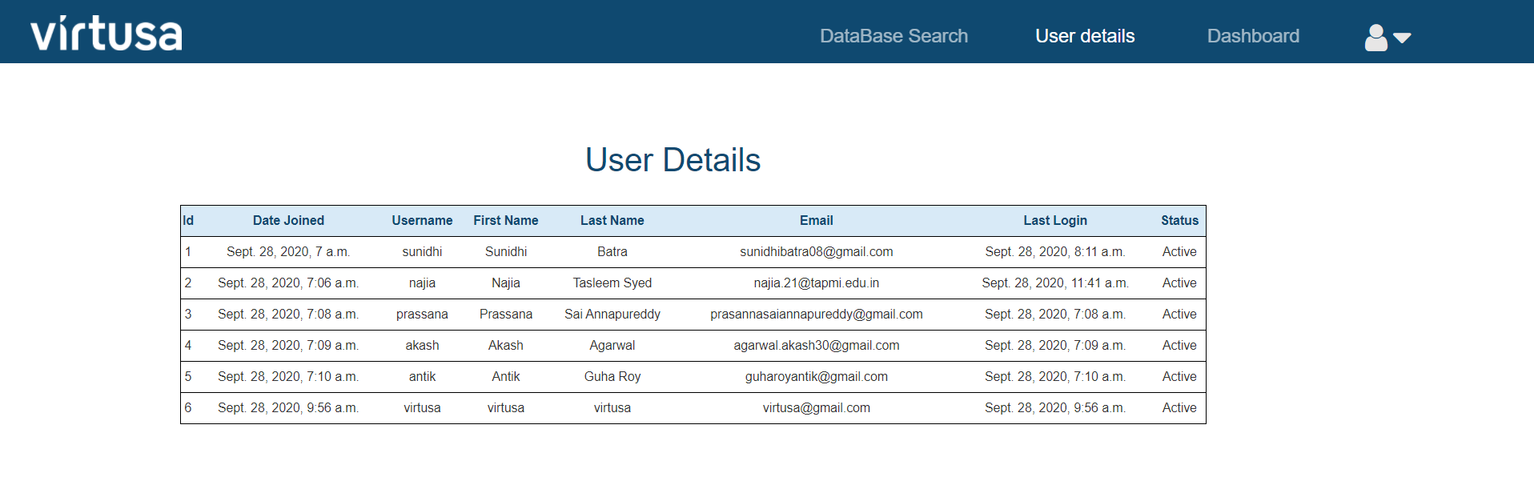

Figure 14 Resource Utilization

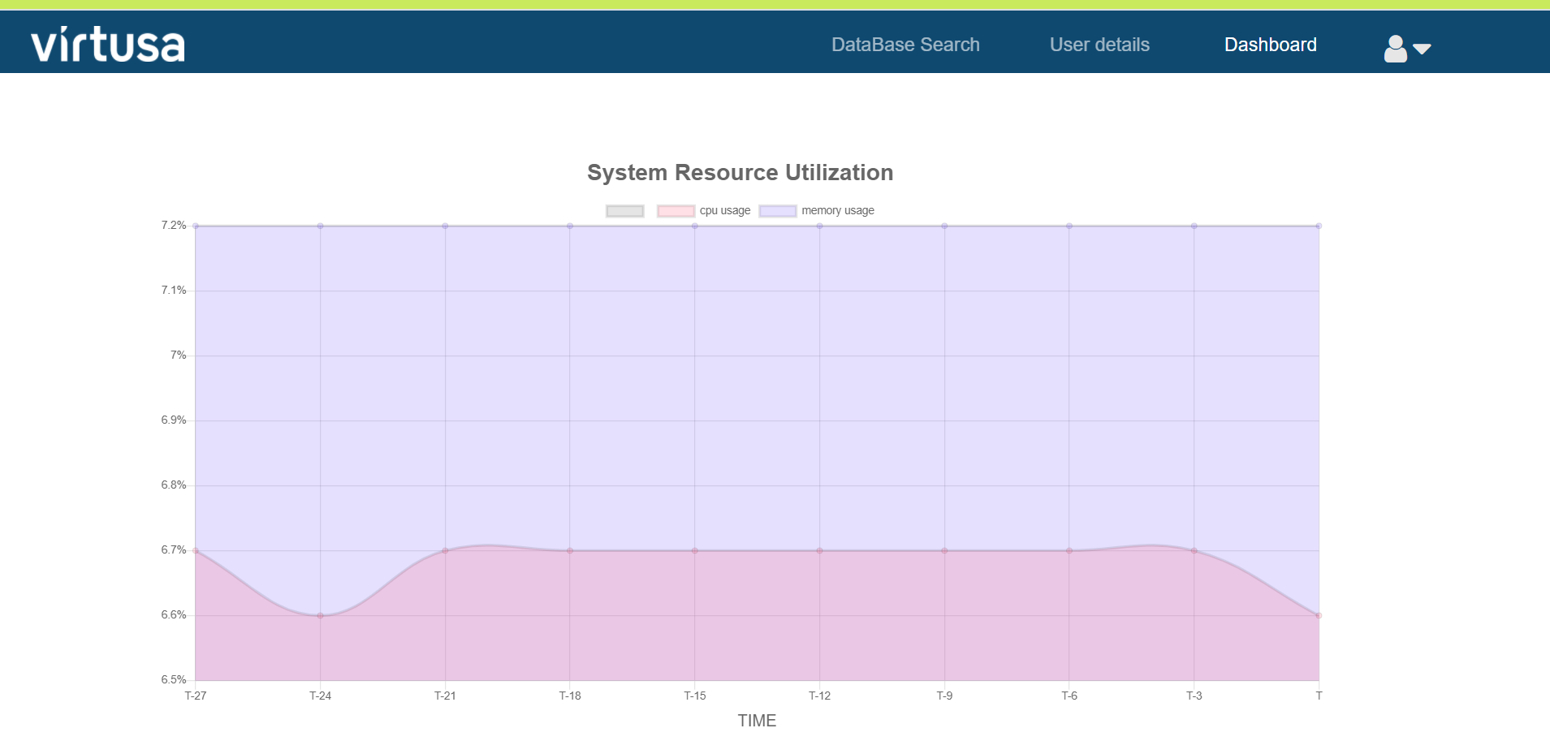

# Chatbot

we have incorporated Dialog Flow services to integrate chatbot to user website. Chatbot is developed using Dialogflow Essentials Cloud console.

Refer: <https://dialogflow.com/documentation>

The basic implementation of the chatbot was based on the following aspects:

* + Intents
  + Conversational flow
  + Integration of chatbot
  + Greeting and fall-back

Chatbot is trained to provide solutions for user queries or FAQ’s related to prediction form fields and other pages in the Web application

Small Talk feature is also added to the Chatbot, where-in user can start a small conversation with the chatbot.

Figure 15 Chatbot

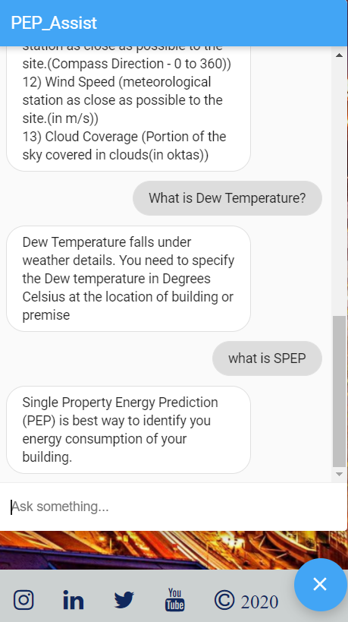

We have given a messenger format to the chatbot and enabled triggered welcome message as and when user login and lands on home page.

# Other UI Screen

Figure 16 Single Input Screen

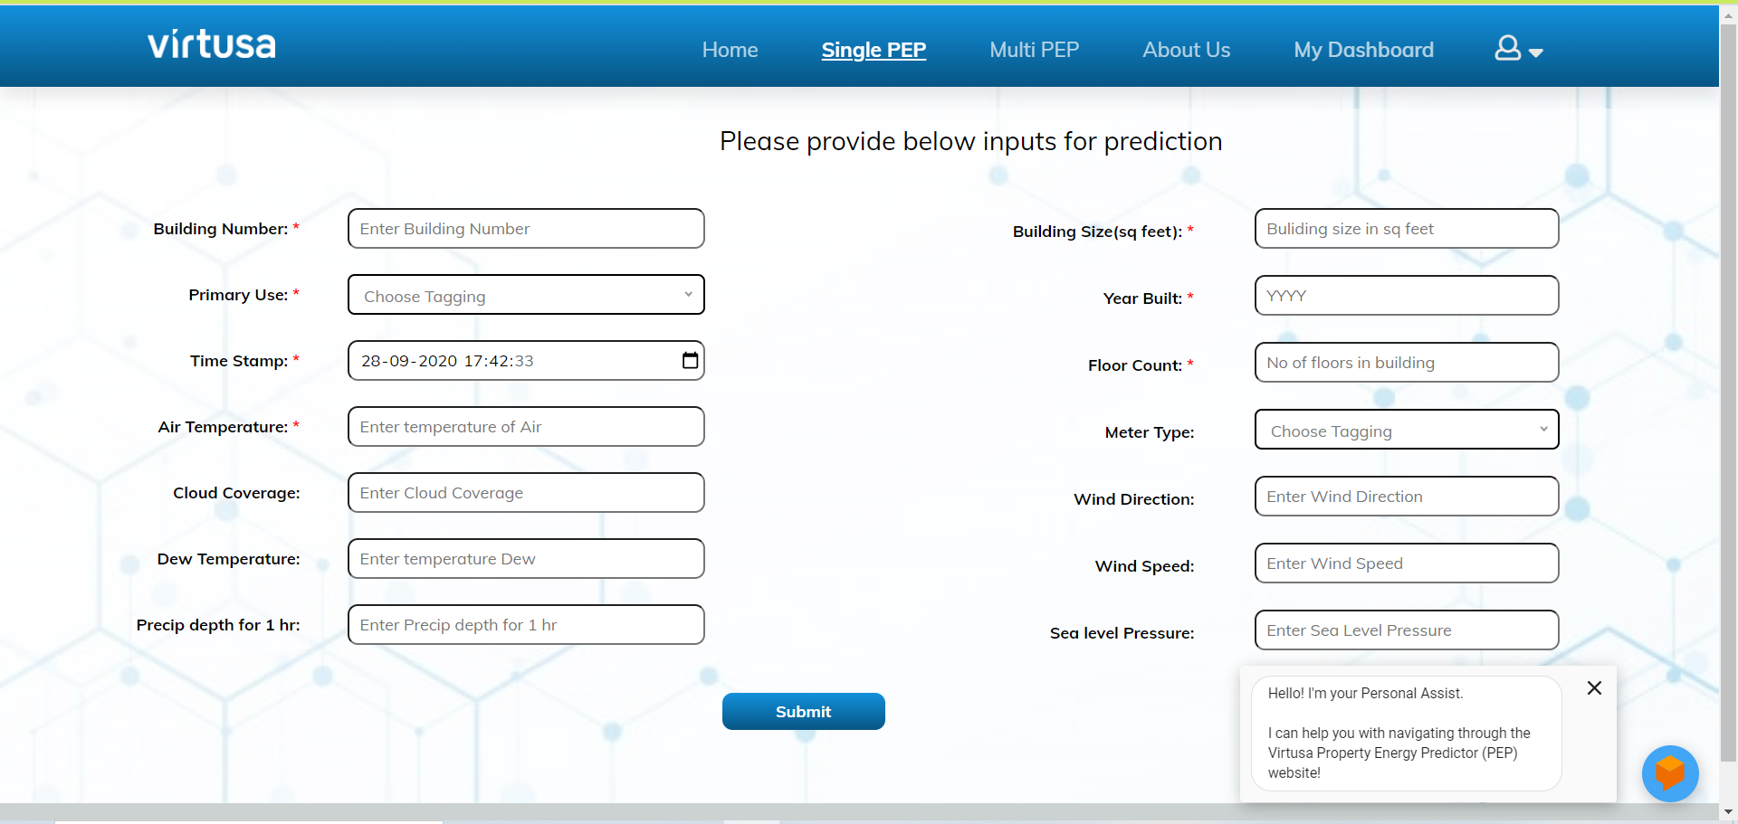

Figure 17 Home Screen

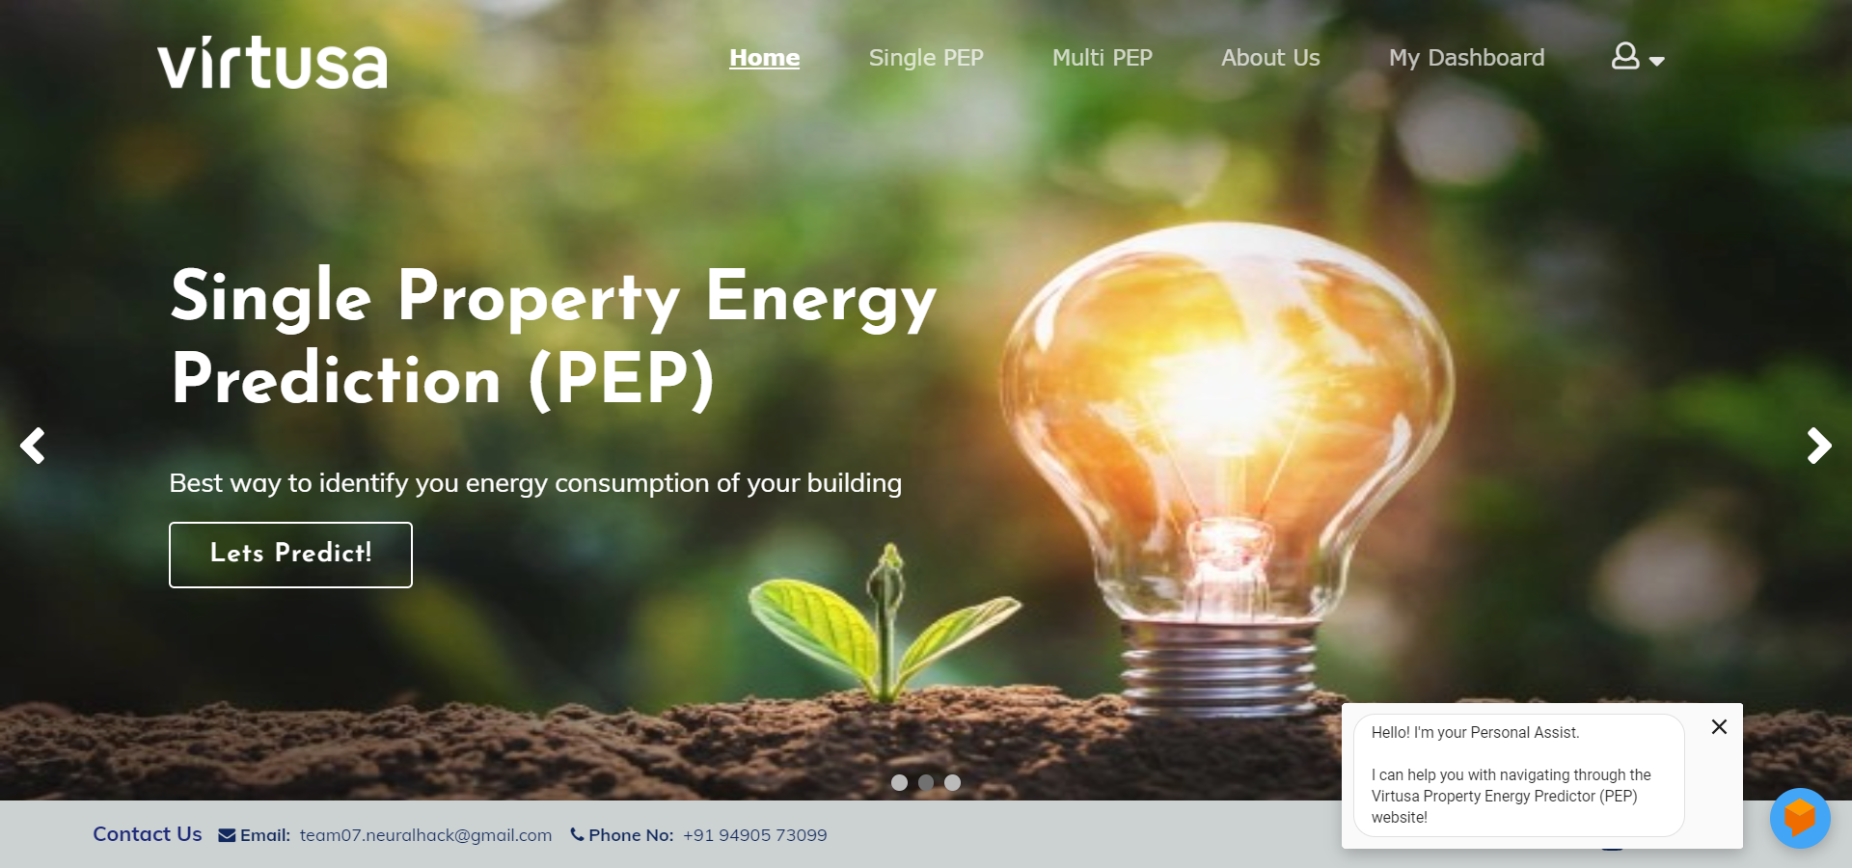

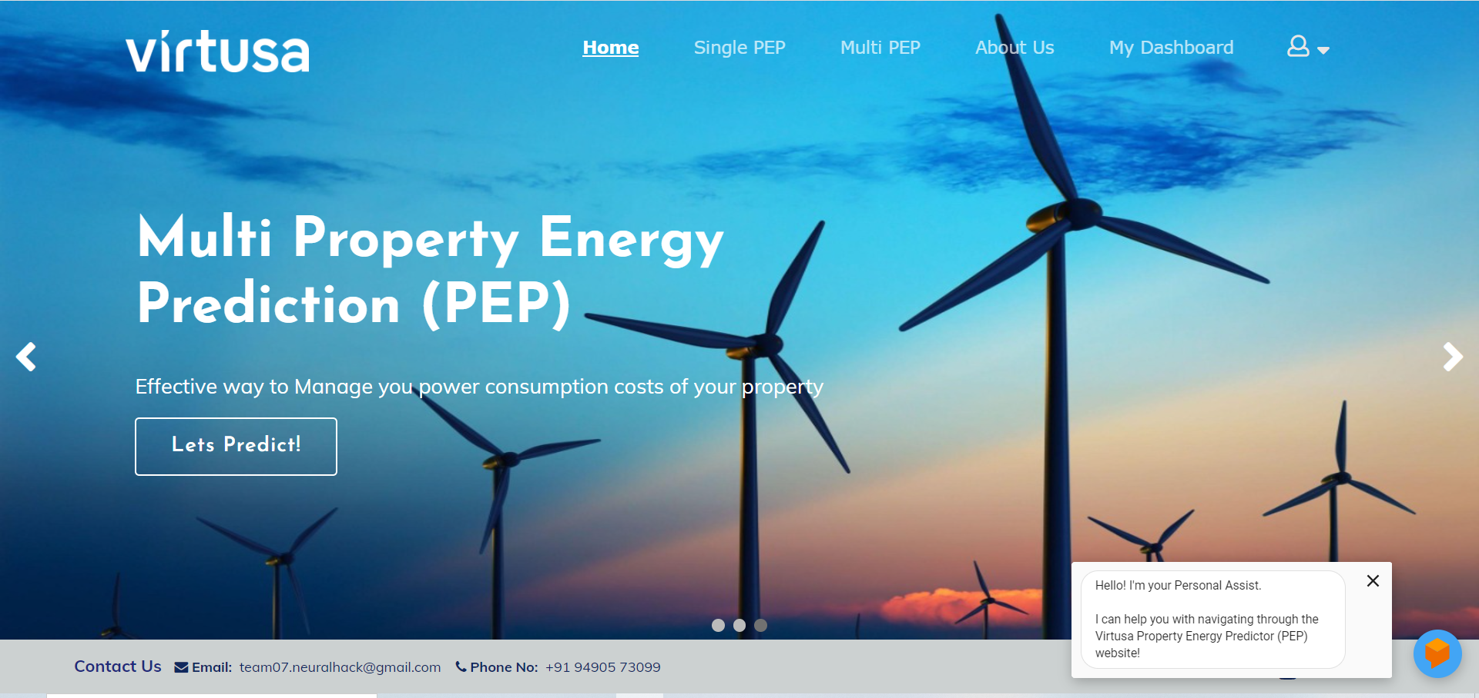

Figure 18 About US

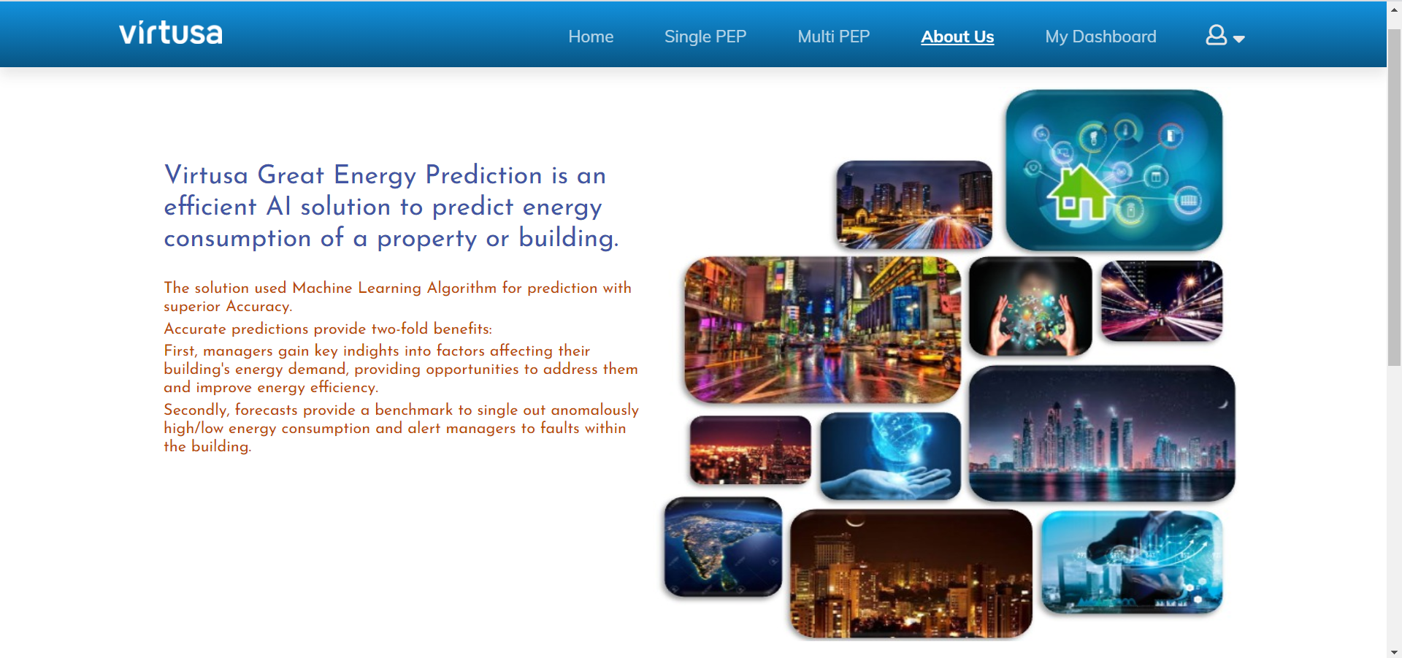

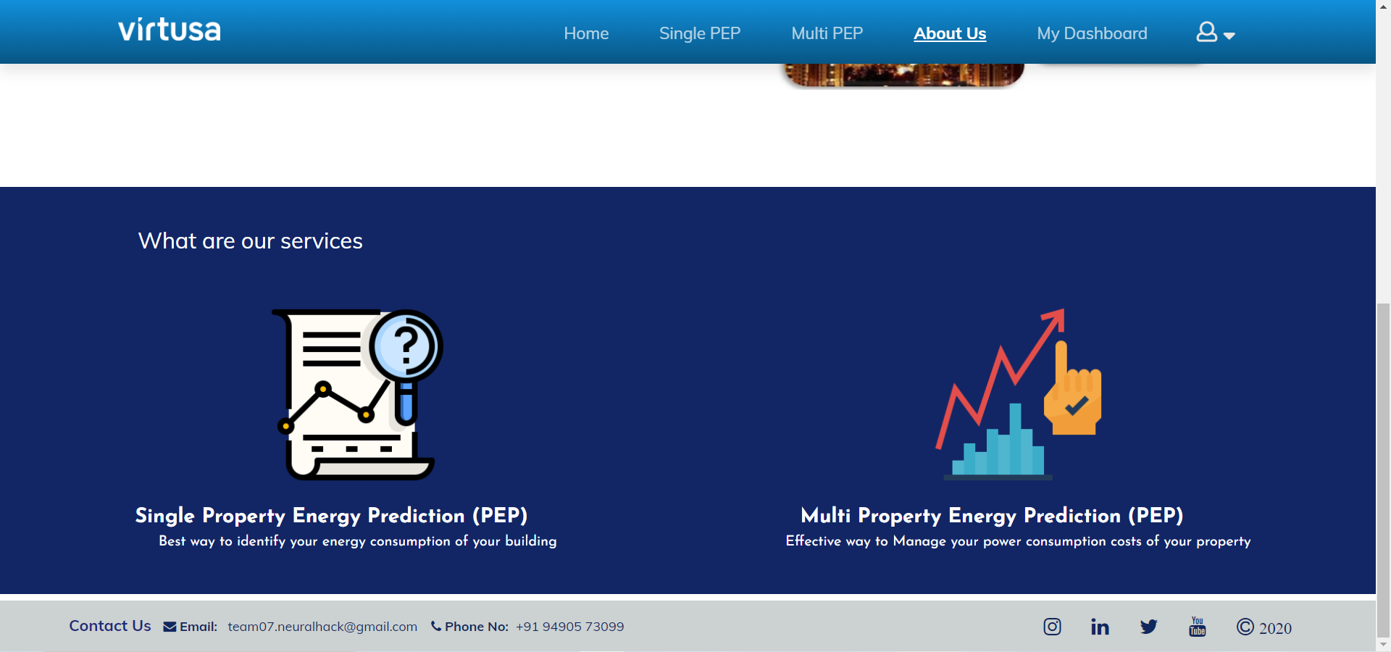

Figure 19 User Profile Screen

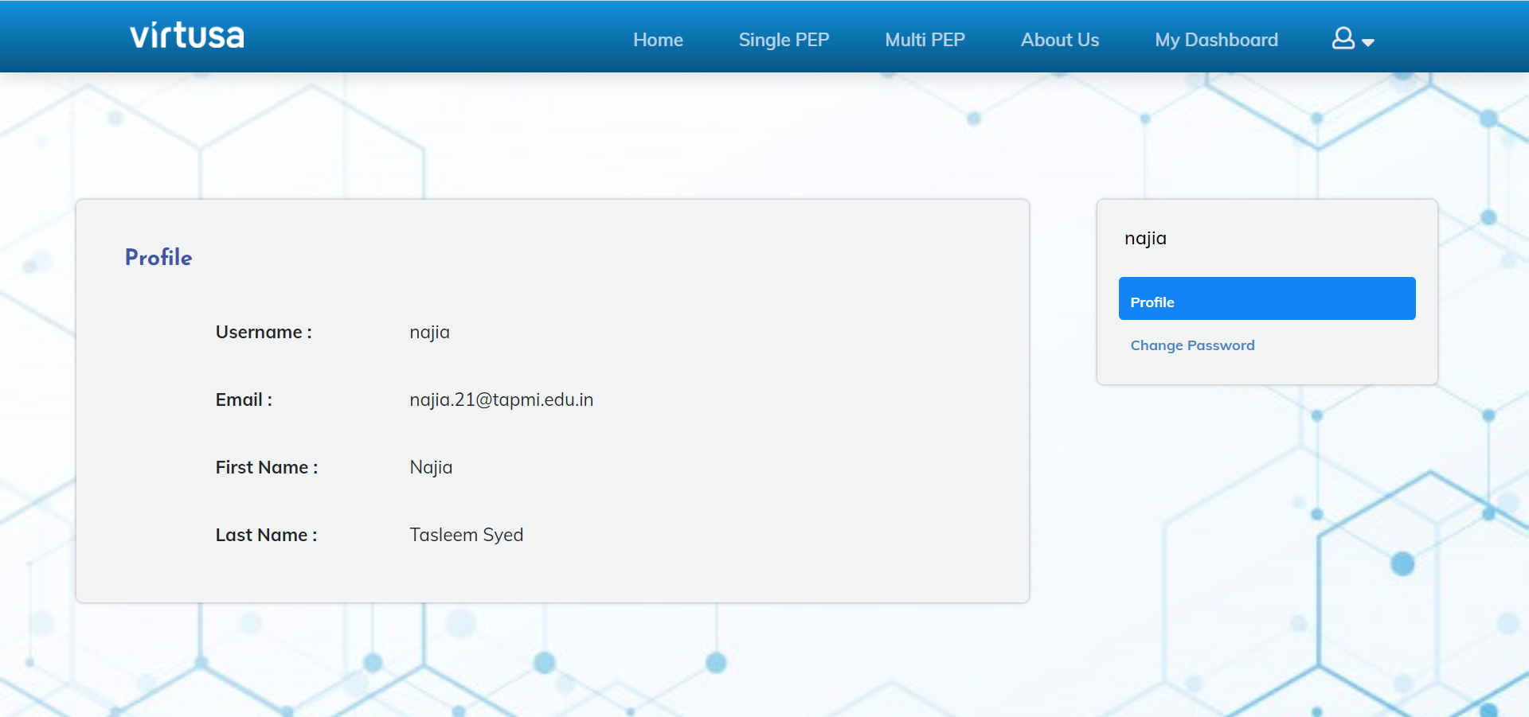

# References

1. <https://www.chartjs.org/>
2. <https://dialogflow.cloud.google.com/#/agent/pep-assist-rdxk/integrations>
3. <https://www.dexma.com/blog-en/forecasting-energy-consumption-using-machine-learning-and-ai/>
4. <https://www.dexma.com/blog-en/forecasting-energy-consumption-using-machine-learning-and-ai/>
5. <https://developer.mozilla.org/en-US/docs/Learn/Server-side/Django/Introduction>
6. <https://developer.mozilla.org/en-US/docs/Learn/Server-side/Django/Introduction>
7. <https://docs.djangoproject.com/en/3.1/ref/databases/>